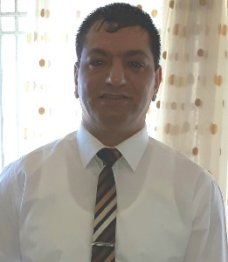
Mustafa Kasapoğlu
Address: Girne, Yasemin Sok. Öztek Apt 30 C No:2
Phone: 0548 881 09 11
Email: kasapoglu_29@yahoo.co.uk
Birth date: 09.03.1975
Objective and Personal Statement
Looking to obtain a teaching job in a reputable University. To build a long-term career as a teacher in a position that offers opportunities for career growth, and to keep up with cutting-edge teaching technologies.
Resourceful English Language Teacher with 10 years of experience with students between ages 5 and 18+. Successful at creating innovative lesson plans to enhance every step of English teaching and learning.

Education and Certificates

Girne American University
Certificate of Attendance 3rd Annual ELT conference on Theoretical and Practical Applications of Emergent Technology in ELT classrooms.
1st April 2011

Girne American University
BA in English Language Teaching
Graduated in June 2003

Girne Anafartalar Lisesi
Graduated June1995
Experience

English Teacher, 14th April 2014 – 04th October 2019
Merit Royal Casino

Duties and Responsibilities
Teach and improve the staff's level of spoken English as well as teaching occupational English to all departments staff within the casino, Prepare comprehensive English curriculum for the casino staff. Implemented lesson plans covering required skills to improve communication skills. Evaluate comprehension of English and oral communication skills.

English lecturer, 2003 – 2006
Girne American University Foundation Department

Duties and Responsibilities
Teach according to the given curriculum and prepare lesson plans. Prepare exam and test papers, invigilate exams and mark exams papers.

Skills

Advanced verbal communication skills
Attention to detail and organization
Patience
Tolerance
Decision making
Critical thinking
Organization and planning
Self-motivation
High levels of energy
Flexibility

Software
Microsoft Office (Excel, PowerPoint, Word)

Personal Interests
Music production, BMX Riding, cooking and surfing the net for the latest technology and methodologies used for improving language learning and teaching.

Reference available on request

